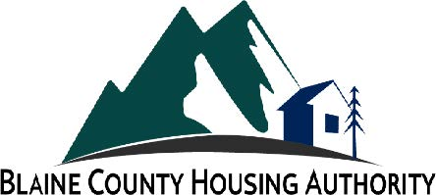 | BLAINE COUNTY HOUSING AUTHORITY  Wednesday, May 08, 2024, 12:00 PM  111 N. First Ave., Suite 2P, Hailey, Idaho 83333

MEETING NOTICE

PUBLIC PARTICIPATION INFORMATION
Public information on this meeting is posted outside City Hall.

We welcome you to watch Board Meetings via live stream.
You will find this option on our website at www.ketchumidaho.org/meetings.

If you would like to comment on a public hearing agenda item, please select the best option for your participation:

• Join us via Zoom (please mute your device until called upon)
Join the Webinar: https://zoom.us/j/92594802380
Webinar ID: 92594802380

• Address the Board in person at Ketchum City Hall or the Meriwether Building in Hailey dependent upon the meeting location.

• Submit your comments in writing at info@bcoha.org (by 8am the day of the meeting)

